**Install Nagios in Ubuntu 14.04**

[***Nagios***](https://www.nagios.org/about/) is the most popular, open source, powerful monitoring system for any kind of infrastructure. It enables organizations to identify and resolve IT infrastructure problems before they affect critical business processes. Nagios has the capability of monitoring application, services, entire IT infrastructure.

1. **Install Pre-requirements module for Nagios.**

# apt-get install apache2

# apt-get install -y php5 libapache2-mod-php5 php5-mcrypt php5-cli

# apt install wget unzip zip autoconf gcc libc6 make apache2-utils libgd-dev

1. **Install Nagios Core in Ubuntu.**

# useradd nagios

# usermod -a -G nagios www-data

# wget <https://assets.nagios.com/downloads/nagioscore/releases/nagios-4.3.4.tar.gz>

# tar xzf nagios-4.3.4.tar.gz

# cd nagios-4.3.4/

# ls

1. **Now, start to compile Nagios from sources by issuing the below commands. Make sure you configure Nagios with Apache sites-enabled directory configuration by issuing the below command.**

# ./configure --with-httpd-conf=/etc/apache2/sites-enabled

1. **In the next step, build Nagios files by issuing the following command.**

# make all

1. **Now, install Nagios binary files, CGI scripts and HTML files by issuing the following command.**

# make install

1. **Next, install Nagios daemon init and external command mode configuration files and make sure you enable nagios daemon system-wide by issuing the following commands.**

# make install-init

# make install-commandmode

1. **Next, run the following command in order to install some Nagios sample configuration files needed by Nagios to run properly by issuing the below command.**

# make install-config

1. **Also, install Nagios configuration file for Apacahe web server, which can be fount in /etc/apacahe2/sites-enabled/ directory, by executing the below command.**

# make install-webconf

1. **Next, create nagiosadmin account and a password for this account necessary by Apache server to log in to Nagios web panel by issuing the following command.**

# htpasswd -c /usr/local/nagios/etc/htpasswd.users nagiosadmin

1. **To allow Apache HTTP server to execute Nagios cgi scripts and to access Nagios admin panel via HTTP, first enable cgi module in Apache and then restart Apache service and start and enable Nagios daemon system-wide by issuing the following commands.**

# a2enmod cgi

# service apache2 restart

# service nagios start

1. **Finally, log in to Nagios Web Interface by pointing a browser to your server’s IP address or domain name at the following URL address via HTTP protocol. Log in to Nagios with nagiosadmin user the password setup with htpasswd script.**

<http://IP-Address/nagios>

**OR**

<http://DOMAIN/nagios>

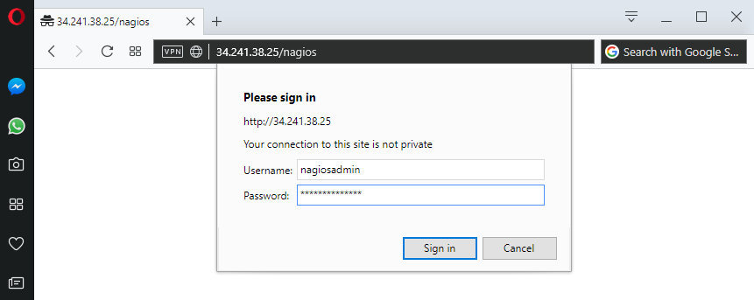

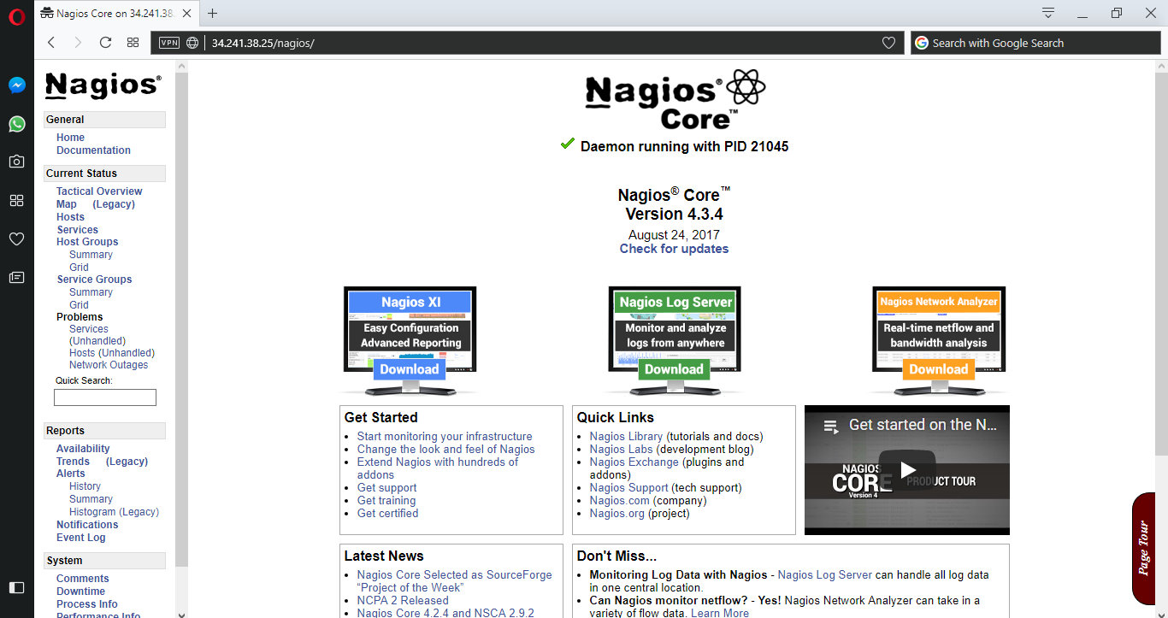

1. **To view your hosts status, navigate to Current Status -> Hosts menu where you will notice that some errors are displayed for localhost host, as illustrated in the below screenshot. The error appears because Nagios has no plugins installed to check hosts and services status.**

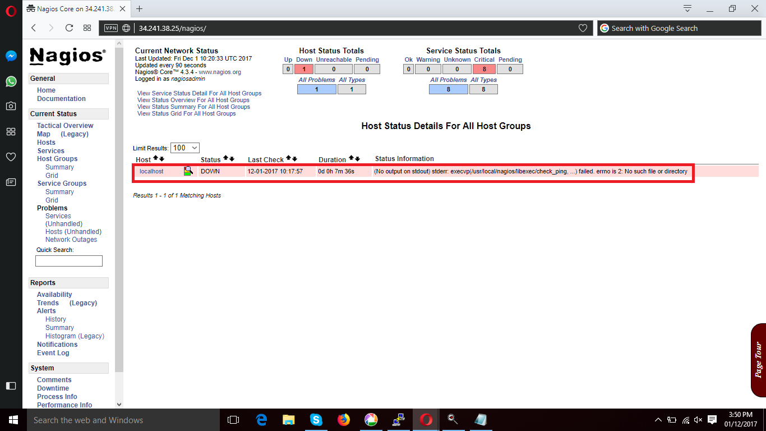

1. **Now, Install Nagios Plugins.**

# apt install libmcrypt-dev make libssl-dev bc gawk dc build-essential snmp libnet-snmp-perl gettext libldap2-dev smbclient fping libmysqlclient-dev qmail-tools libpqxx3-dev libdbi-dev

1. **Next, visit Nagios Plugins repositories page and** [**download the latest source code tarball**](https://github.com/nagios-plugins/nagios-plugins/releases) **by issuing the following command.**

# wget <https://github.com/nagios-plugins/nagios-plugins/archive/release-2.2.1.tar.gz>

1. **Go ahead and extract the Nagios Plugins source code tarball and change path to the extracted nagios-plugins directory by executing the following commands.**

# tar xfz release-2.2.1.tar.gz

# cd nagios-plugins-release-2.2.1/

1. **Now, start to compile and install Nagios Plugins from sources, by executing the following series of commands in your server console.**

# ./tools/setup

# ./configure

# make

# make install

1. **The compiled and installed Nagios plugins can be located in /usr/local/nagios/libexec/ directory. List this directory to view all available plugins in your system.**

# ls /usr/local/nagios/libexec/

1. **Finally, restart Nagios daemon in order to apply the installed plugins, by issuing the below command.**

# service nagios restart

1. **Next, log in to Nagios web panel again and go to Current Status -> Services menu and you should notice all hosts services are checked now by Nagios plugins. From the color code you should see the current services status: green color is for OK status, yellow for Warning and red for Critical status.**

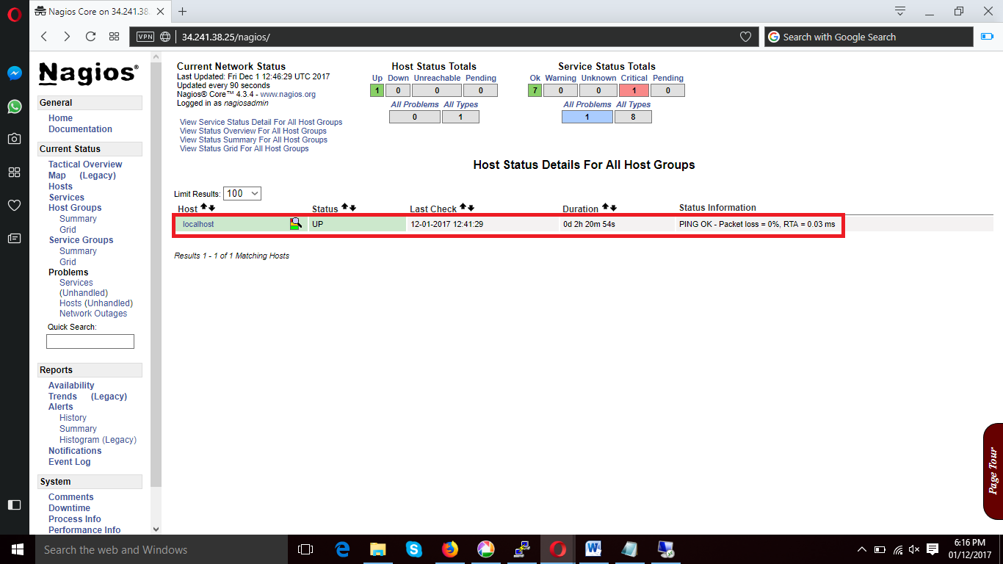

# *Add Windows Host to Nagios Monitoring Server*

**Windows** machines “**private**” services such as **CPU load**, **Disk usage**, **Memory usage,** **Services**, etc. For this, we required to install an **NSClient++** addon on the **Windows** machine. The addon acts a proxy between the **Windows** machine and **Nagios** and monitors actual services by communicating with the **check_nt** plugin. The **check_nt** plugin already installed on the **Nagios Monitoring Server.**

1. **Install NSClient++ Agent on the Remote Windows Host. First download the latest stable version of NSClient++ , which can be found at below link.**

<http://sourceforge.net/projects/nscplus/>

Once you’ve downloaded latest stable version of NSClient++ , Install .exe file.

Click on Next -> click on Accept terms -> Click on Typical and Next -> Next

Provide **Nagios Server IP**, and **Enter Password for NSClient** and Click on All Check Boxes -> Install.

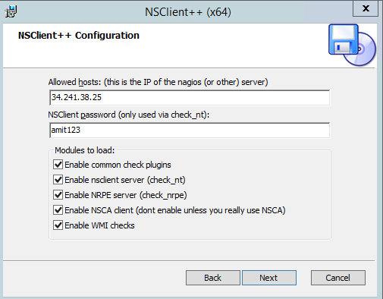

1. **Open the Windows Services Manager and right click on  NSClient  go to Properties and then ‘Log On‘ tab and click the check box that says “Allow service to interact with the desktop“. If it isn’t already allowed, please check the box to allow it to.**

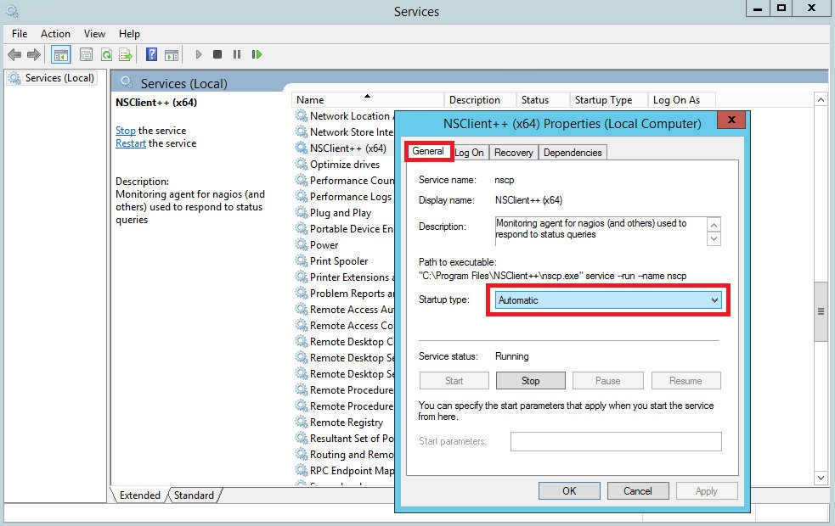

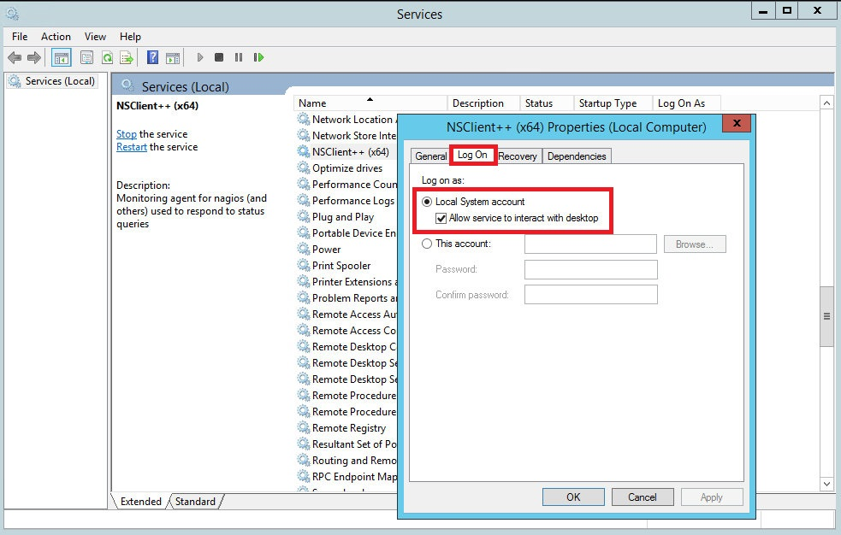

1. **After that open NSClient++ installation Folder** located at “ **:\Program Files\NSClient++”**  directory, Open “nsclient” Configuration File and add the client port no.

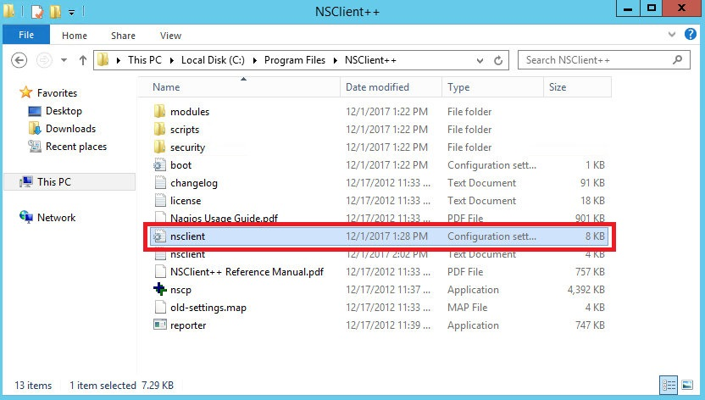

**Nsclient configuration file looks like this :-**

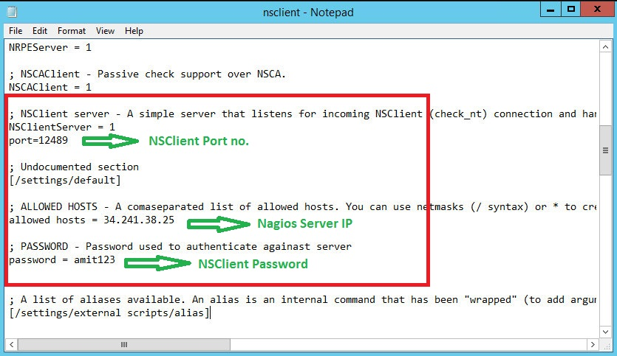

1. **After that Double click on nscp application file for run the start the Application.**

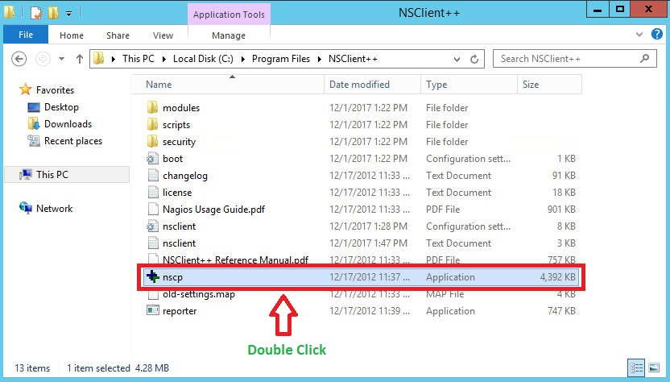

### Now, Add this Windows Hosts to Nagios Server. For that move to Nagios Server Machine and Configured this Windows hosts.

1. Login into **Nagios Server** and add some **object definitions** in **Nagios** configuration files to monitor new **Windows** machine. Open **windows.cfg** file for editing with **any** editor.

root@**nagios-server**:~# vim /usr/local/nagios/etc/objects/**windows.cfg**

A sample Windows host definition already defined for the Windows machine, you can simply change the host definition like **host_name**, **alias**, and **address** fields to appropriate values of your **Windows** machine.

Also already added and enabled in windows Services. If you wish to add some more other service definitions that needs to be monitored, you can simple add those definitions to same configuration file. Make sure to change the host_name for these all services with host_name defined.

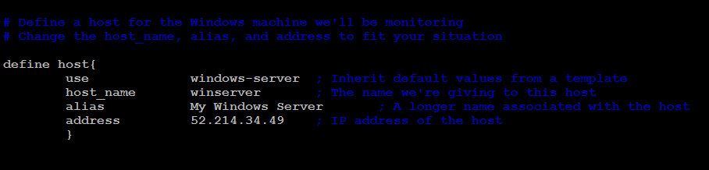

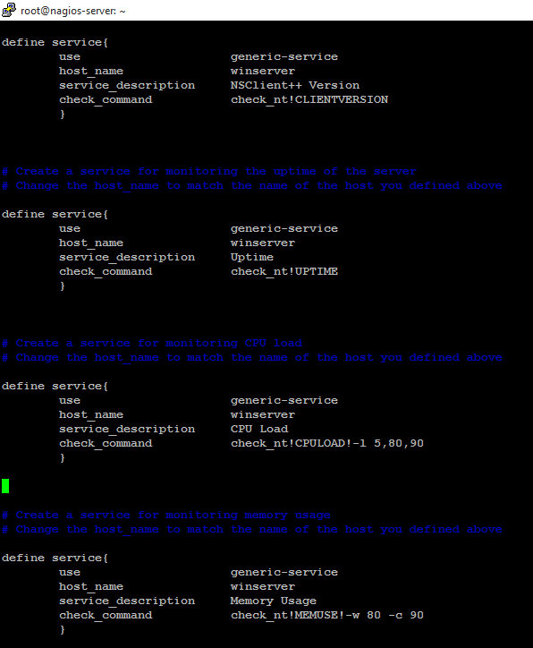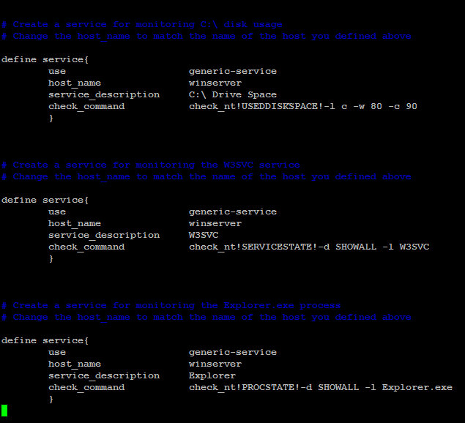

1. Lastly, uncomment the windows.cfg file in /usr/local/nagios/etc/nagios.cfg.

# vim /usr/local/nagios/etc/nagios.cfg

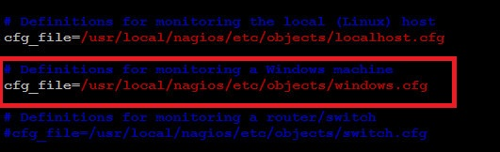

1. Add/Define **check_nt** commands in **“commands.cfg”** file for windows host to communicate with each Others machine. This file Will be available at “/**usr/local/nagios/etc/objects**”. Just find “**check_nt**” command and Add the password of Windows Remote host NSClient++ .

# vim /usr/local/nagios/etc/objects/**commands.cfg**

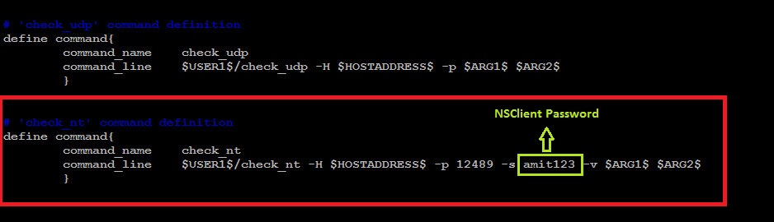

1. Finally, **verify the Nagios configuration** files for any erros.

# /usr/local/nagios/bin/nagios -v /usr/local/nagios/etc/nagios.cfg

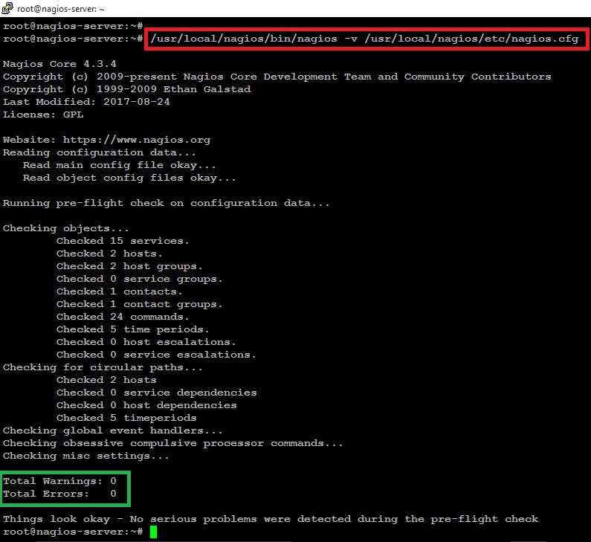

1. If the verification process throws any error messages, fix those errors until the verification process completes without any error messages. Once’ you fix those errors, restart the Nagios service.

**# service apache2 restart**

**# service nagios restart**

1. That’s it. Now go to Nagios Monitoring Web interface at “**http://Your-server-IP-address/nagios**” or “**http://FQDN/nagios**” and Provide the username “**nagiosadmin**” and password. Check that the **Remote Windows Host** was added and is being monitored.

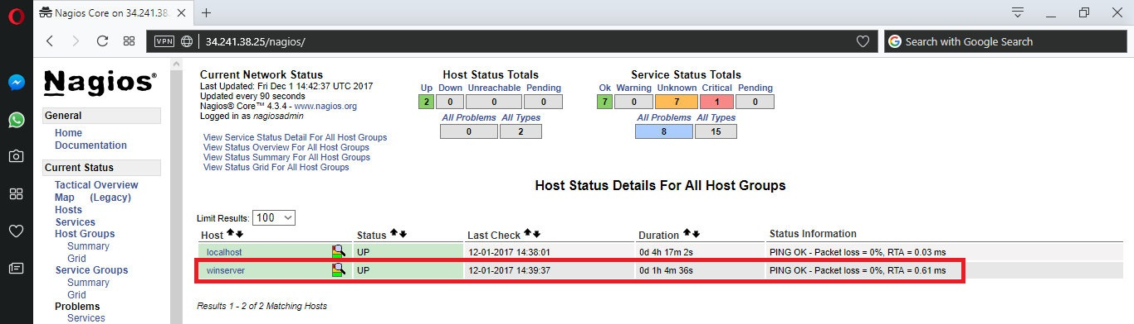

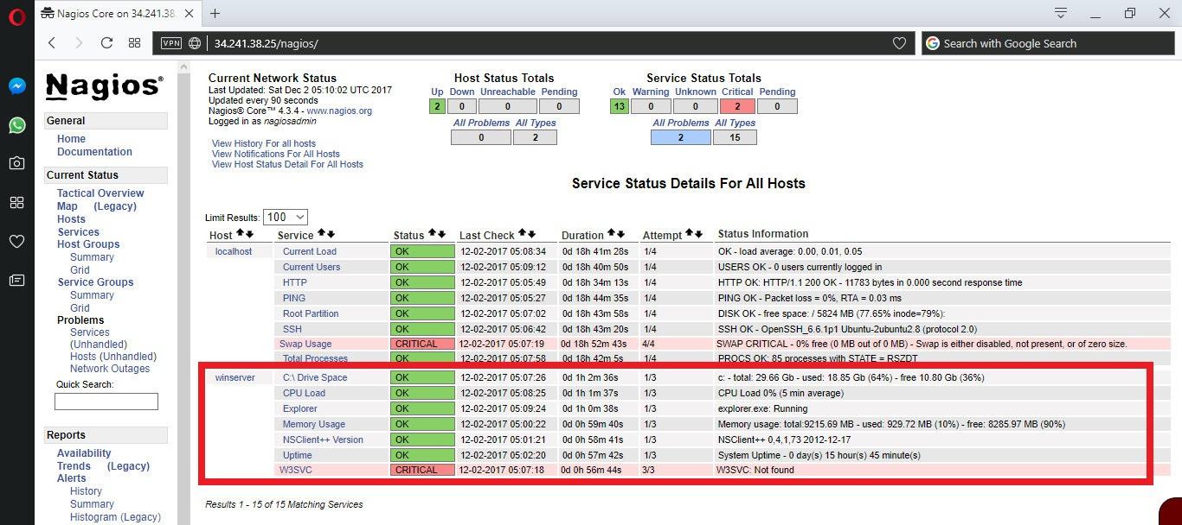

***Reference Url :-***

* <https://www.tecmint.com/how-to-add-windows-host-to-nagios-monitoring-server/>
* <https://www.2daygeek.com/add-remote-windows-host-on-nagios-server-to-monitor/>

# *Add Unix Host to Nagios Monitoring Server*

1. In Remote host run the following Commands.

# sudo apt-get update

1. Now install Nagios Plugins and NRPE.

# sudo apt-get install nagios-plugins nagios-nrpe-server

1. Now, let's update the NRPE configuration file. Open it in your favorite editor.

# sudo vim /etc/nagios/**nrpe.cfg**

Find the allowed_hosts directive, and add the private IP address of your Nagios server to the comma-delimited list (substitute it in place of the highlighted example)

allowed_hosts=127.0.0.1**,34.241.38.25**

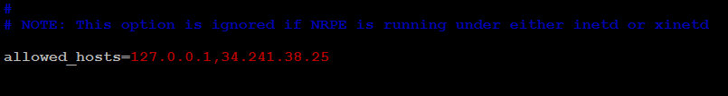

**Find server_address**: Set to the private IP address of this host (client_IP), also add the Port no.

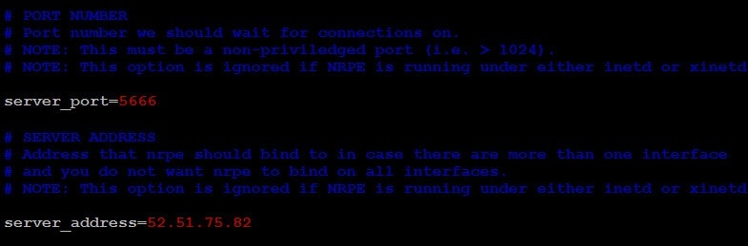

We will be using the filesystem name in the NRPE configuration to monitor your disk usage, For that Add following Line and comment existing “Check_hda1” command.

Comment following Command :-

**#**command[check_hda1]=/usr/lib/nagios/plugins/check_disk -w 20% -c 10% -p /dev/xvda1

Add following Command :-

command[check_disk]=/usr/lib/nagios/plugins/check_disk -w 20% -c 10% -p /

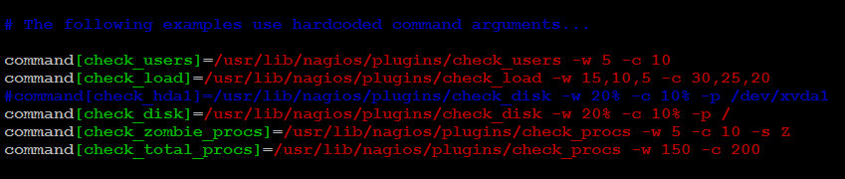

Note that there are several other "commands" defined in this file that will run if the Nagios server is configured to use them. Also note that NRPE will be listening on port 5666 because server_port=5666 is set. If you have any firewalls blocking that port, be sure to open it to your Nagios server.

Save and quit file.

1. Restart NRPE to put the change into effect:

**# service nagios-nrpe-server restart**

Once you are done installing and configuring NRPE on the hosts that you want to monitor, you will have to add these hosts to your Nagios server configuration before it will start monitoring them.

1. **Move to Nagios Server**. On your Nagios server, create a new configuration file for each of the remote hosts that you want to monitor in **“/usr/local/nagios/etc/objects”** Location.

# cd usr/local/nagios/etc/objects

I am monitoring my geoserver machine services, so I am create **geoserver.cfg** file. Replace the highlighted word, "geoserver", with the name of your host.

# vim geoserver.cfg

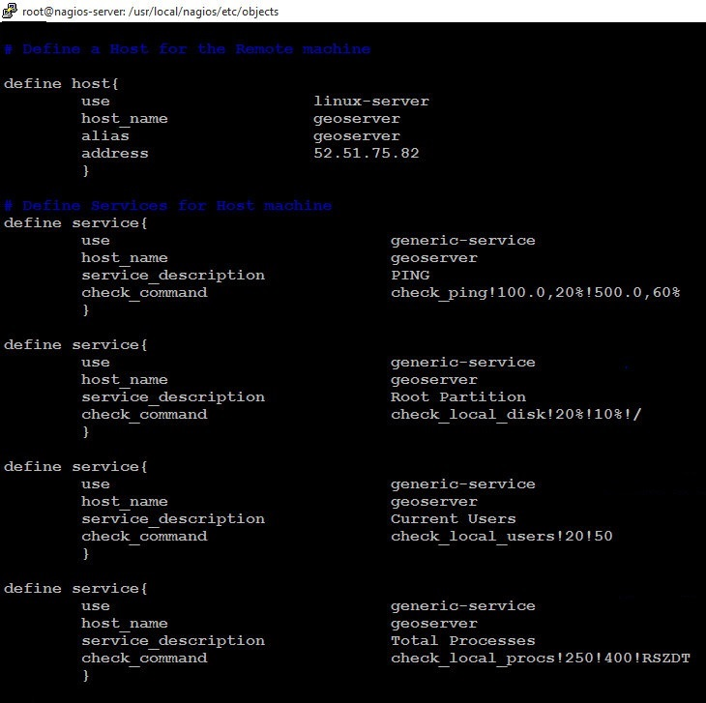

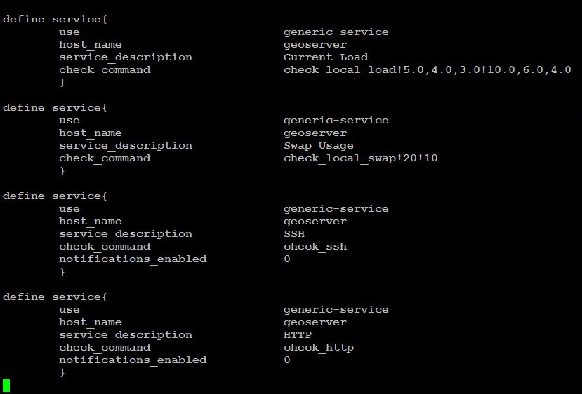

1. Also add your host.cfg file ie. geoserver.cfg file with full path in nagios configuration nagios.cfg file located in /usr/local/nagios/etc/

# cd usr/local/nagios/etc

# vim nagios.cfg

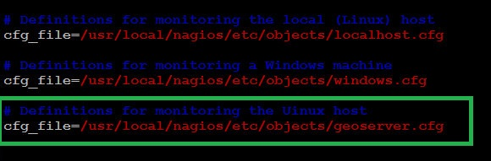

1. Restart the Nagios service.

**# service nagios restart**

1. That’s it. Now go to Nagios Monitoring Web interface at “http://Your-server-IP-address/nagios” and Provide the username “nagiosadmin” and password. Check that the Remote Linux Host was added and is being monitored.

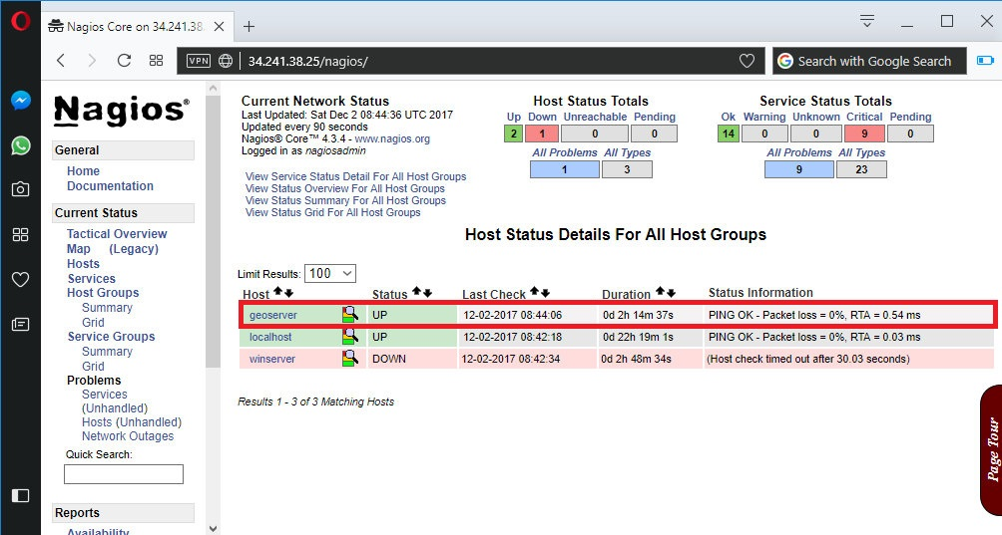

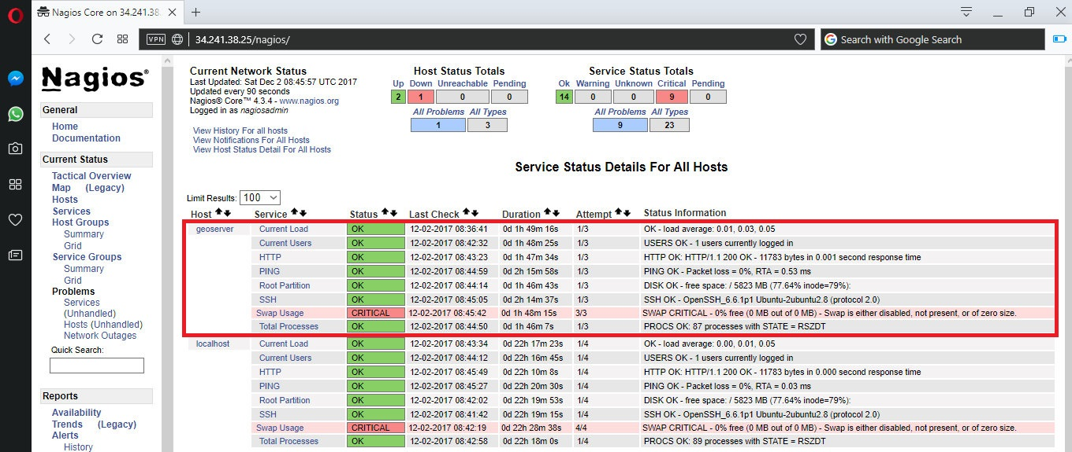

***Reference Url :-***

* <https://www.digitalocean.com/community/tutorials/how-to-install-nagios-4-and-monitor-your-servers-on-ubuntu-14-04>
* <https://www.tecmint.com/how-to-add-linux-host-to-nagios-monitoring-server/>
* <https://www.server-world.info/en/note?os=Ubuntu_16.04&p=nagios&f=6>

***Note :-***

Suppose, you want to monitor others service, than simply check that service using **Port no** of this Service. I want to monitor Mysql service of host machine so define port no of mysql usind **check_tcp** command.

# vim /usr/local/nagios/etc/objects/geoserver.cfg

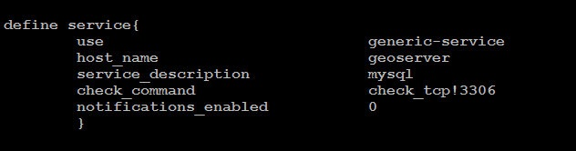

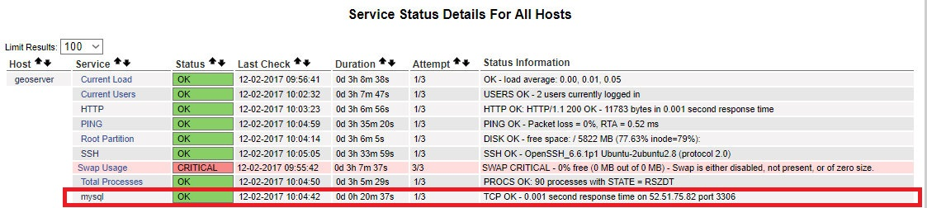

Email :-

# apt-get install libio-socket-ssl-perl libnet-ssleay-perl perl

# apt-get install 'perl(Net::SSLeay)' 'perl(IO::Socket::SSL)'

# wget <http://caspian.dotconf.net/menu/Software/SendEmail/sendEmail-v1.56.tar.gz>